 | 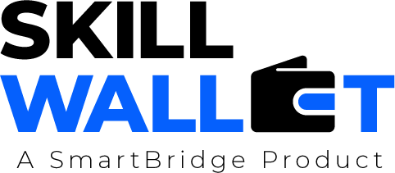
Project Initialization and Planning Phase
Date | 11 July 2026
Team ID
Project Title | EduGenie – Google Gemini Powered Learning Assistant
Team Members | Garugu Vikas (Team Lead)  Adarsh Singh  Bhavanadithya Kopparapu  Lavanya Lahari Konduru  M Ramita Saraswati
Maximum Marks | 5 Marks

Project Proposal (Proposed Solution) Report
Project Overview
Objective | To simplify and enhance the learning experience through Generative AI by providing intelligent educational support — helping users understand concepts, answer questions, generate quizzes, summarize learning material, and receive personalized learning recommendations.
Scope | A lightweight AI-powered educational assistant for students, self-learners, and educators, built with a FastAPI backend and a responsive HTML + CSS frontend, combining lightweight local models with cloud-based AI services (Google Gemini) to deliver fast, accurate assistance across academic levels and subject domains, optimized to run on resource-constrained devices such as the Mac M1.
Problem Statement
Description | Students, self-learners, and educators often lack a single accessible, lightweight, and personalized tool for instant doubt resolution, concept explanation, self-assessment, and structured learning guidance — relying instead on fragmented resources such as private tutors, generic search engines, or heavy, costly ed-tech platforms.
Impact | Solving this makes learning more interactive, accessible, and efficient across academic levels — improving concept retention through instant doubt resolution and self-assessment, and enabling personalized, guided learning paths for students, self-learners, and educators.
Proposed Solution
Approach | Combining lightweight local models with cloud-based Generative AI services (Google Gemini) through a FastAPI backend and a responsive HTML + CSS frontend to deliver fast and accurate educational assistance.
Key Features | - Intelligent Question Answering  - Simplified Concept Explanations  - AI-Powered Quiz Generation  - Educational Text Summarization  - Personalized Learning Path Recommendations  - Interactive and User-Friendly Interface

Resource Requirements
Resource Type | Description | Specification/Allocation
Hardware
Processor | CPU specification | Intel i3 / i5 or higher
Memory | RAM specification | Minimum 4 GB (8 GB Recommended)
Storage | Disk space for data, models, and logs | 10 GB Free Disk Space
Network | Connectivity requirement | Internet Connection Required
Software
Operating System | Supported platforms | Windows / Linux / macOS
Frameworks | Backend framework | FastAPI (Python 3.10+)
AI Service | Generative AI provider | Google Gemini API
Development Environment | IDE / Editor | Visual Studio Code / PyCharm
Version Control | Source control & hosting | Git & GitHub
Data
Database | Source, format | SQL / PostgreSQL / SQLite

